**Assignment 1**

|  |  |
| --- | --- |
| **Date** | **01-10-2022** |
| **Team ID** | **PNT2022TMID37463** |
| **Project Name** | **Signs with Smart Connectivity for Better Road Safety** |

IBM IOT Assignment 1: Interface piezo alarm with 2 sensor:PIR sensor and temperature sensor, use these sensors along with piezo buzzer and write simple logic that the piezo alarm operates whenever the temperature is above 60 degree centigrade and when ever the motion is detected.

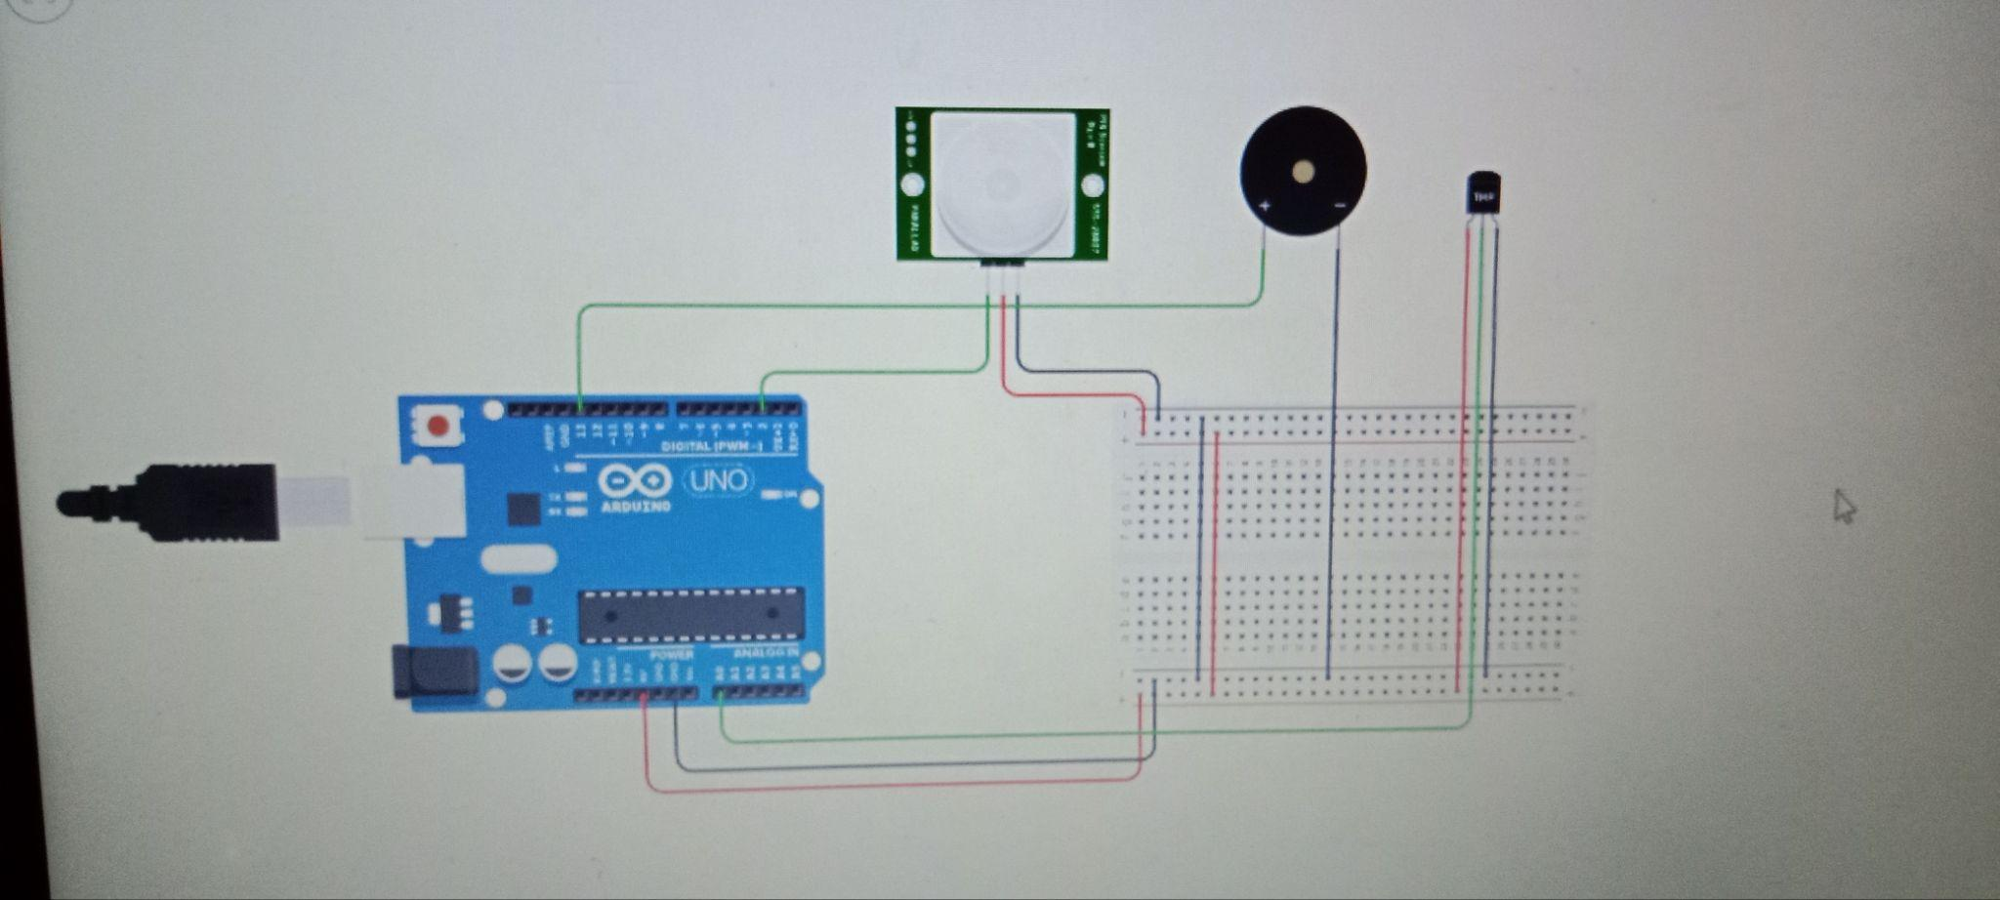

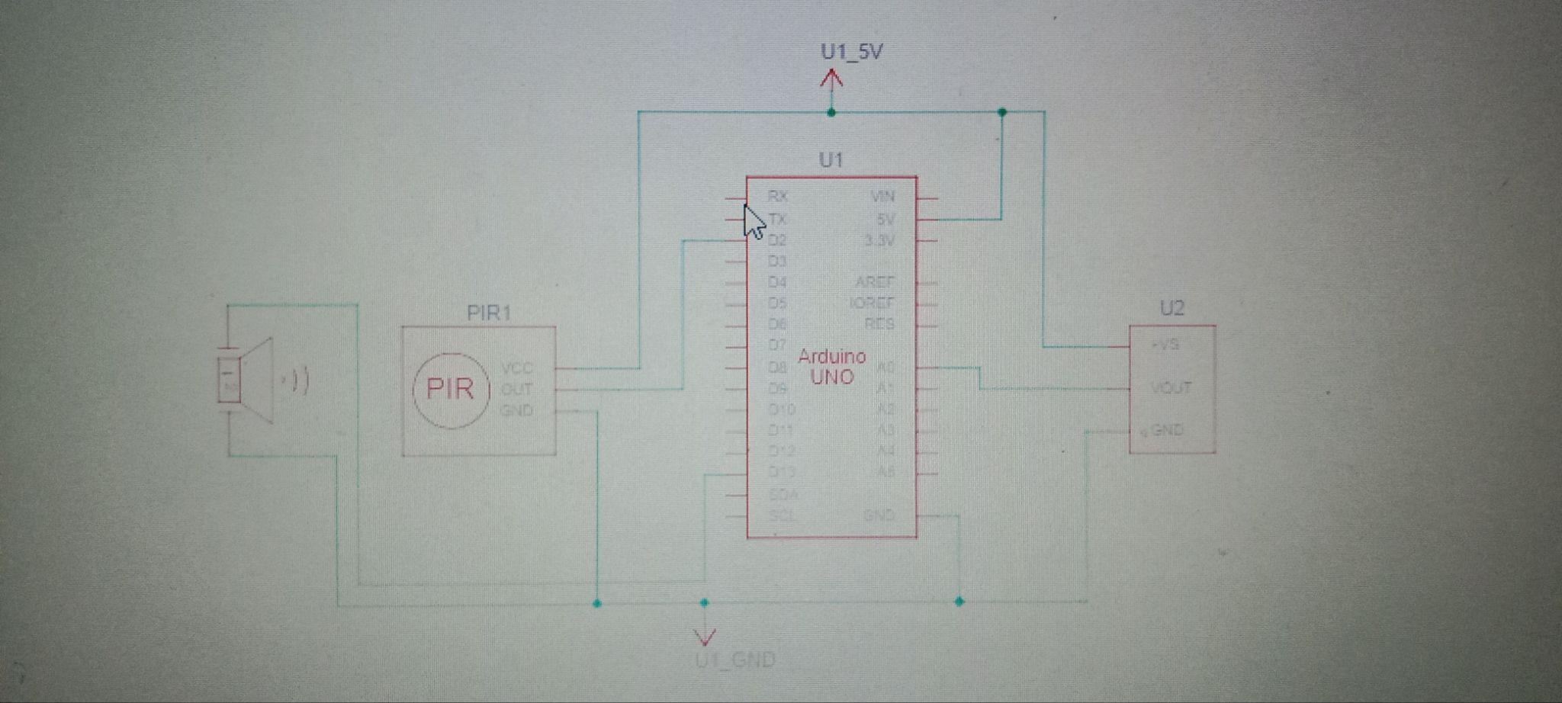

Code:

intbaselineTemp = 0;

intcelsius = 0;

int motion=digitalRead(2);

void setup()

{

pinMode(A0, INPUT);

pinMode(2, INPUT);

Serial.begin(9600);

pinMode(13, OUTPUT);

}

void loop()

{

baselineTemp =60; celsius = map(((analogRead(13) - 20) * 3.04), 0, 1023, -40, 125);

if (celsius<baselineTemp)

{

digitalWrite(13, LOW);

}

if (celsius>baselineTemp)

{

digitalWrite(13, HIGH);

for(intfreq=0;freq<=30000;freq++)

tone(13, freq);

delay(1000);

noTone(12);

delay(500);

}

if (motion==1)

{

digitalWrite(13, HIGH);

for(intfreq=0;freq<=30000;freq++)

tone(13, freq);

delay(1000);

noTone(12);

delay(500);

}

}